ACN Chapter 1 – Network Layer & Protocols
*MSBTE, Computer Engineering Semester 5*

1. Network Layer: Role and Responsibilities

What is the Network Layer?
- Responsible for host-to-host delivery of packets across diverse networks.
- Layer 3 in the TCP/IP 5-layer model.
- Interfaces: Receives from Data Link Layer, provides to Transport Layer.

Key Duties
- Internetworking: Logical connection of various networks.
- Addressing: Assigning unique IP addresses to interfaces/devices.
- Routing: Selecting optimal path for data.
- Packetizing: Encapping transport layer data into packets.
- Fragmentation: Dividing packets based on network requirements.

2. IPv4 Addresses

Characteristics
- 32-bit identifier, assigned to every network interface.
- Notations: Binary, Dotted Decimal, Hexadecimal.

Notation Types

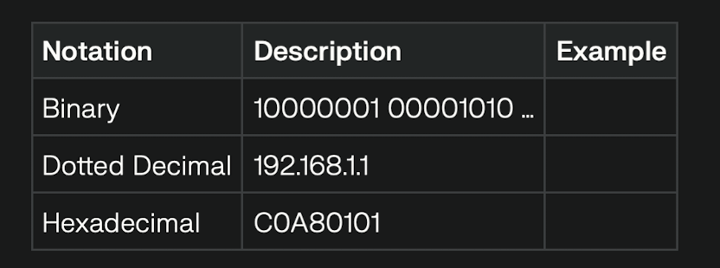
Address Space
- Total: 2^{32} = 4,294,967,296 unique addresses.

Example (Dotted Decimal Conversion)
- Binary: `10010001 00001010 00100010 00000011`
- Decimal: `145.10.34.3`

3. Classful Addressing

IPv4 Classes

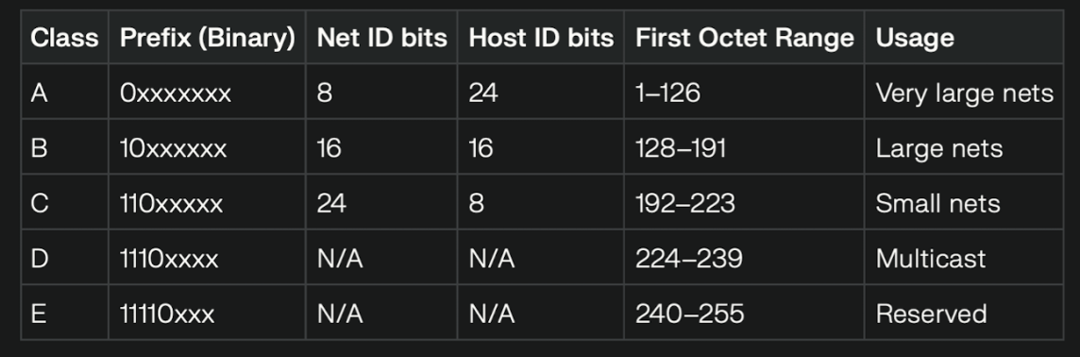
Identifying Classes:
A: 0 – 127
B: 128 – 191
C: 192 – 223
D: 224 – 239
E: 240 – 255

Two-Level Addressing

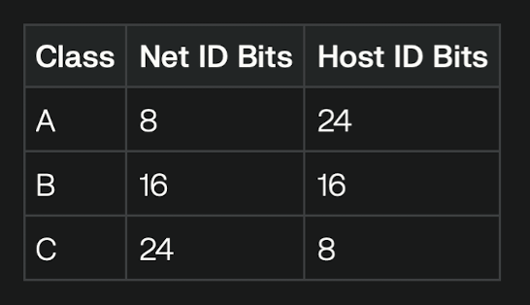

Network Address Extraction:
- Net ID: Identifies network
- Host ID: Host within network
- Example:
- Address: 132.7.21.84 (Class B)
- Net ID: 132.7
- Host ID: 21.84

Default Network Masks

| Class | Default Mask |
|------- |-------------------|
| A | 255.0.0.0 |
| B | 255.255.0.0 |
| C | 255.255.255.0 |

Extracting Network Address:
Apply bitwise AND between IP and mask.
Example: 132.7.21.84 AND 255.255.0.0 = 132.7.0.0

4. Subnetting (Three-Level Addressing)

- Subnetting divides large networks into smaller subnets.
- Requires creating a subnet mask with added bits.

Example (Class C):
- Original: 192.168.1.0/24 (mask: 255.255.255.0)
- 8 subnets: Need 3 extra ones (mask: 255.255.255.224, or /27)

5. Special IP Addresses
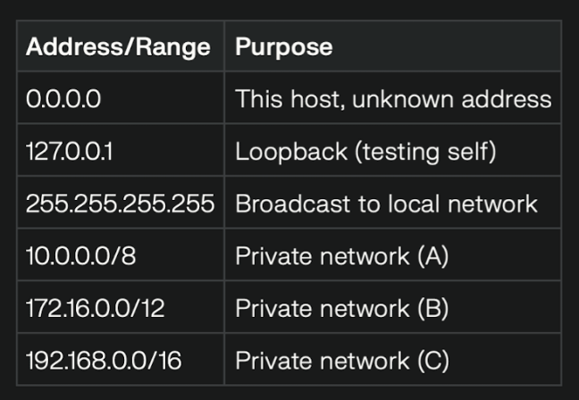

6. Limitations of IPv4

- Address Exhaustion: 32-bit pool is limited.
- Management Difficulties: Rigid hierarchical structure.
- No mobility or built-in security.

7. Classless Addressing (CIDR)

- Abandons fixed classes—allocates variable-size blocks using “slash notation” (e.g., 192.168.1.0/26).
- More efficient address use; supports blocks for small/large needs.

| CIDR Notation | Block Size | Network Mask |
|------------------|-------------------|---------------------|
| 192.168.1.0/24 | 256 addresses | 255.255.255.0 |
| 192.168.1.0/26 | 64 addresses | 255.255.255.192 |
| 192.168.1.0/27 | 32 addresses | 255.255.255.224 |

Example:
- Block: 64.32.16.8/27
- Block size: $$2^{32-27} = 32$$ addresses
- Range: 64.32.16.0 to 64.32.16.31
- Mask: 255.255.255.224

8. Supernetting

- Combines multiple (usually Class C) blocks into one "supernet" for larger organisations.

9. Registered vs. Private (Unregistered) IPs

| Type | Usage | Registration |
|--------------|------------------------|--------------------|
| Registered | Public Internet | Yes (via IANA/ISP) |
| Unregistered | Private LANs/Offices | No (local only) |

10. NAT (Network Address Translation)

- Solves limited public IP space by mapping internal private IPs to one public IP externally.
- Internal addresses are not routable on the public Internet.
- Used widely in company LANs.

11. IPv4 Datagram & Header Format

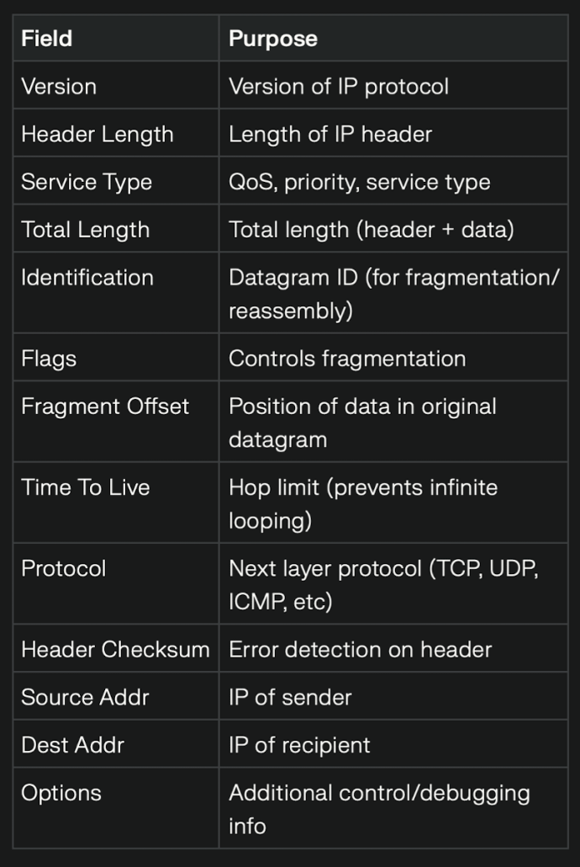
12. Fragmentation & MTU

- Different networks have different MTUs (Maximum Transmission Units).
- IP datagrams may be split (fragmented) to fit these MTUs.
- Each fragment travels independently and is reassembled at destination.

13. IPv4 Header Options

- Single-Byte: No Operation, End of Options
- Multi-Byte: Record Route, Source Routing (Strict/Loose), Timestamp

14. ICMPv4 – Error Control & Diagnosis

- Used for error messages and query functions.
- Error: Destination Unreachable, Time Exceeded, Source Quench, etc.
- Query: Echo (Ping), Timestamp

ICMP Message Format:
- Includes type, code, checksum in header.

15. Mobile IP

- Enables portable devices to maintain the same IP address across networks.
- Uses two IPs: Home Address (permanent), Care-of Address (temporary).
- Agents: Home Agent (HA), Foreign Agent (FA)
- Phases: Discovery, Registration, Data Transfer

16. Virtual Private Network (VPN)

- Extends private networks securely over public infrastructure (like the Internet).
- Uses encryption and tunneling protocols to protect data.

17. Key Network Layer Protocols (Summary Table)

| Protocol | Purpose |
|----------|----------------------------|
| IP | Packet delivery, addressing|
| ICMP | Error reports, diagnostics |
| NAT | Maps private↔public IPs |
| VPN | Secure remote connectivity |

18. Additional Examples

- Finding class of address:
If first octet = 24 → Class A
If first octet = 221 → Class C

- Subnetting Example:
- Network: 192.168.1.0/24
- 4 subnets: Need 2 more bits → /26 mask (255.255.255.192)
- Subnet address ranges:
- 192.168.1.0–63, 64–127, 128–191, 192–255

